Artist Presentation Worksheet

- Who is this? _________________________

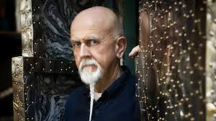
2. What was this artist’s motto? _________________________

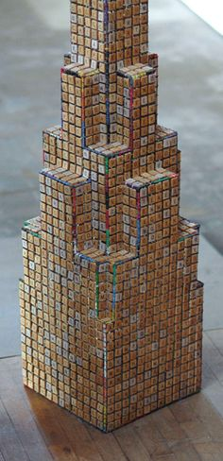 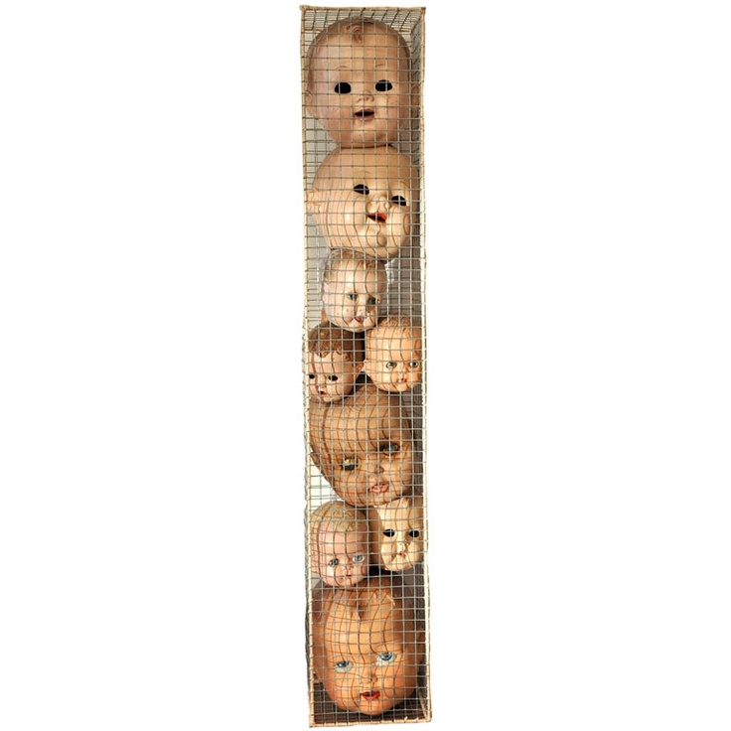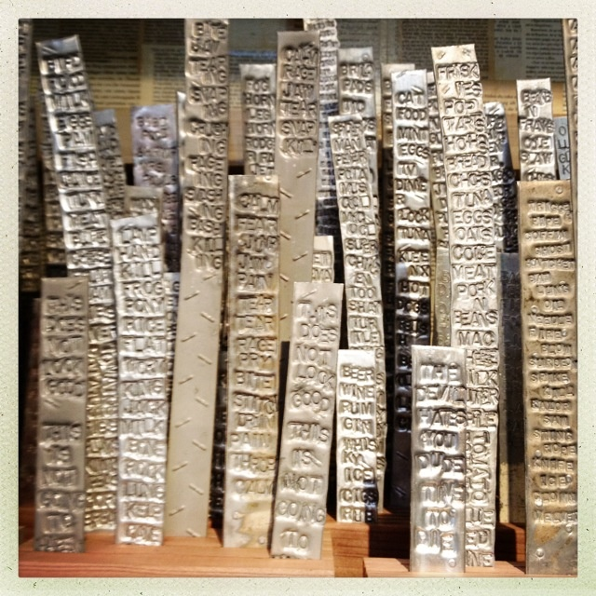 3. What kind of material did this artist tend to collect? ________________________________________

4. What is a specific work of art that this artist has made? _____________________________________
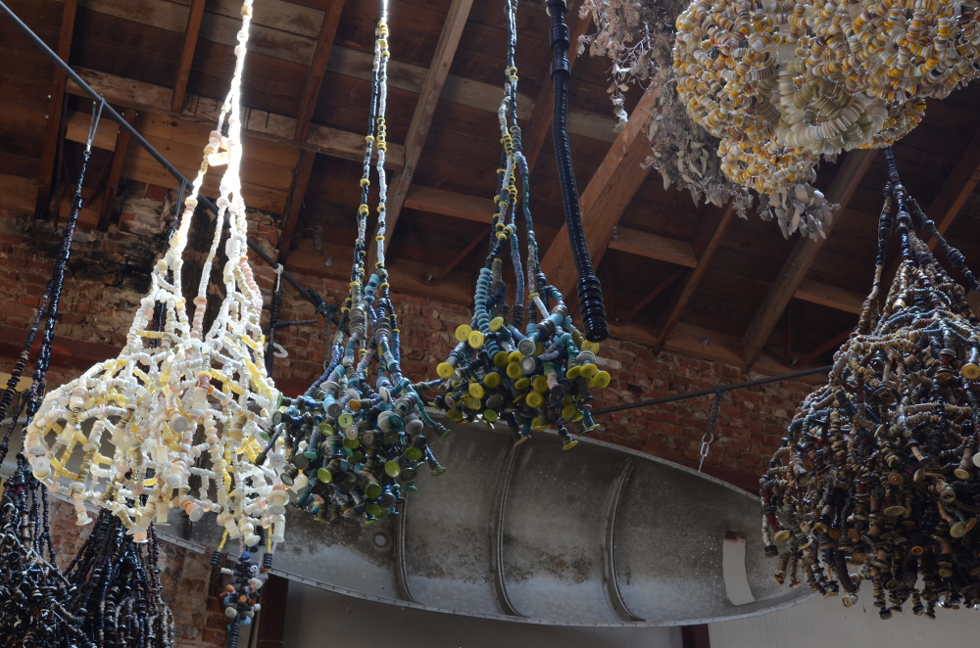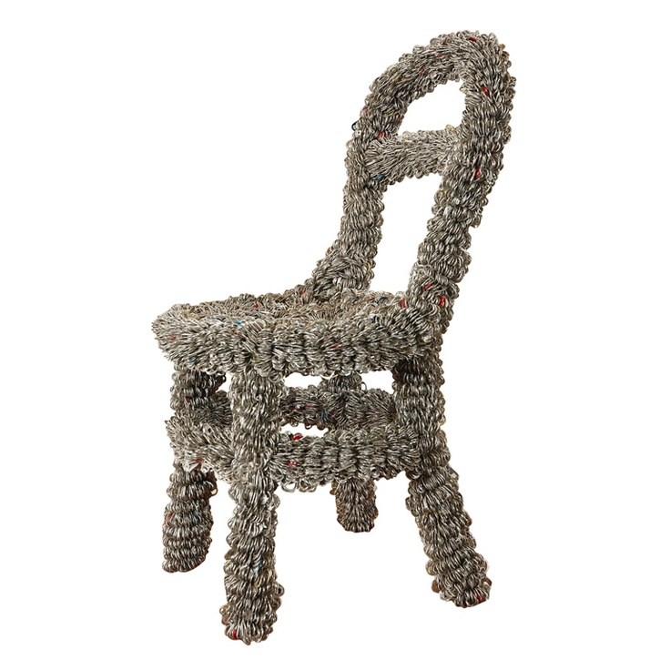

5. How do you think his surroundings have influenced his art? ___________________________________________________________________________________

6. Why do you think people collect recyclable material? What use is there for that? Have you ever collected anything that later became valuable? _____________________________________________________________________________________

